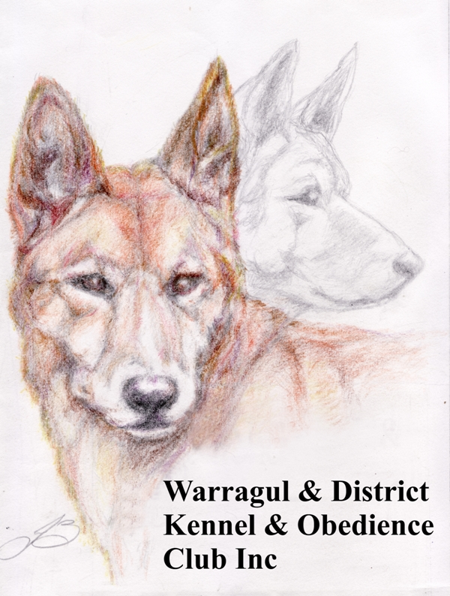

**Warragul and District Kennel and Obedience Club Inc A0015469L**

By-Laws

As adopted at General Meeting dated 14th April 2024

**Preamble**

The Warragul Dog Club provides an enjoyable and inclusive learning environment, with the safety of our dogs and handlers our highest priority. Our instructors in all disciplines are all highly experienced and provide their time and skills on a voluntary basis. Alongside dog and handler safety, instructors will ensure that all participants are provided with a welcoming learning environment. These By Laws provide guidance and direction with regards to the safe, efficient and ethical operation of the Club and will assist in ensuring our members’ experiences with the Club are rewarding and positive.

Subject always to the Act, Dogs Victoria rules and regulations and Rule 44 of this Association, members in general meeting by resolution passed by a majority of not less than three fourths of the members present, and voting in person, may make by-laws and may from time to time amend such by-laws by variation, deletion or addition as they shall think fit in respect of:

1. nominations of members
2. membership fees
3. the conducting of ballots
4. the holding and conducting of Training, Trials, Shows, Exhibitions and other events by the Club
5. the granting of awards and prizes at such events and competitions
6. the manner and procedure of dealing with protests and objections made at competitions and exhibitions, subject always to Dogs Victoria Rules
7. the conduct of Members, Instructors, Committee and Office Bearers
8. Committee and other meetings
9. the publication of a newsletter or journal
10. any other matter the members may consider necessary

**By Law 1**

**Club Logo**

1. The logo of the Club shall be as set out below with or without additional text that may set out the name of the Club.

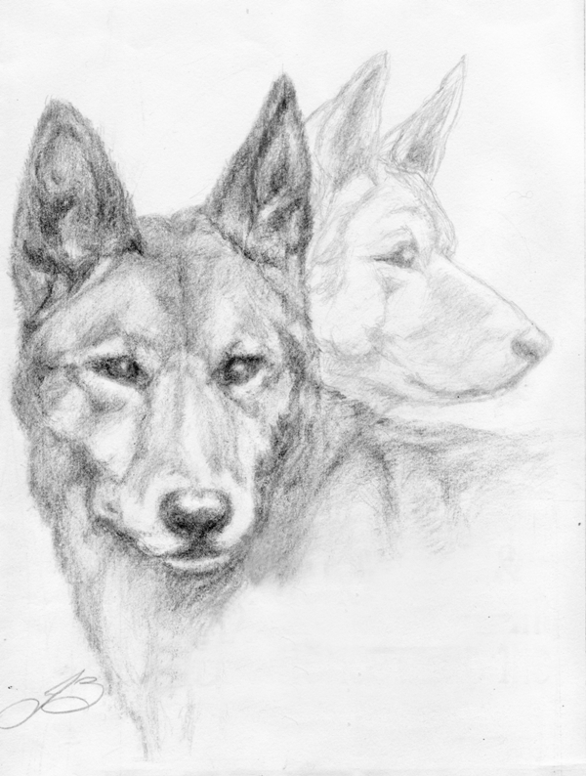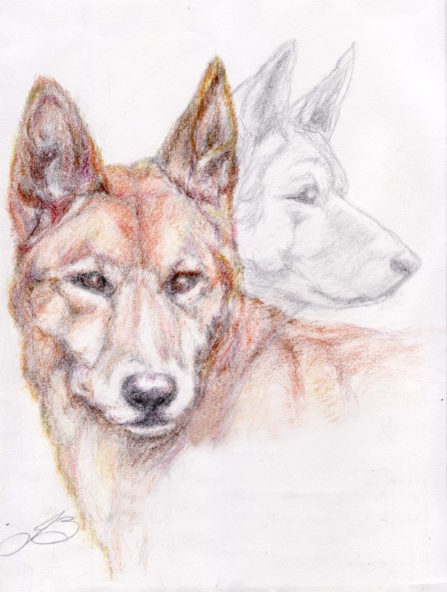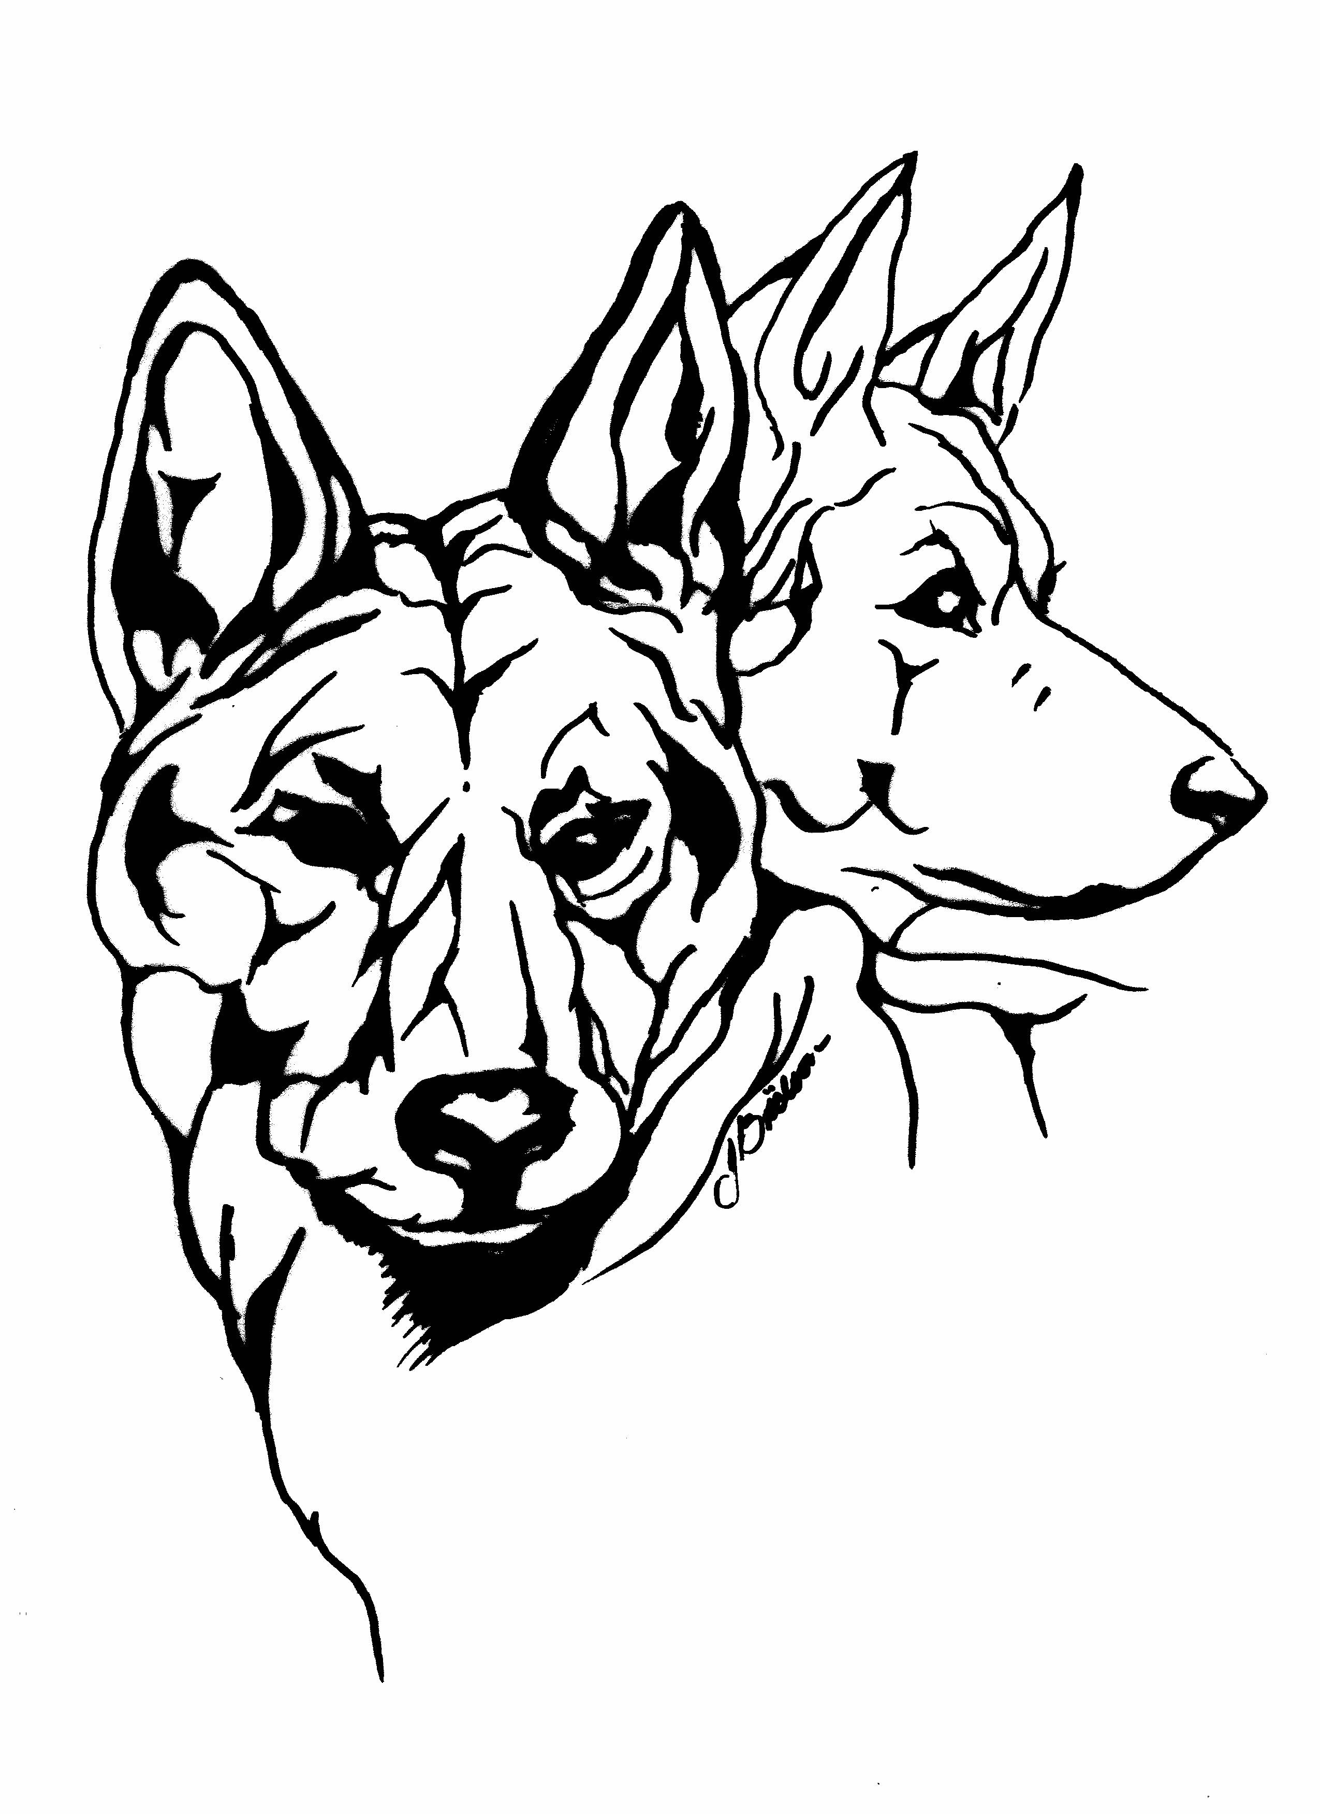

**By Law 2**

1. **Membership Categories**

**In accordance with Rule 14**, a natural person owning a dog, or interested in any of the activities referred to in the Statement of Purposes of the Club, who is nominated and approved for membership as provided in these rules, may be admitted to membership of the Club under the following categories.

1. **Single Membership**. A natural person, a single individual who meets the membership requirements. An Ordinary Member.
2. **Family Membership**. A group of natural persons who are a family unit, who meet the membership requirements.
3. **Life Membership**. A natural person who, as a consequence of outstanding service given to the Club over a period of at least 10 years, is admitted as a Member for Life, retaining all of the membership rights to vote or to hold Office whilst not being required to pay any membership fee or subscription.
4. **Honorary Membership**. A natural person, who as a consequence of outstanding service given to the Club, may be admitted as an Honorary Member. The payment of any fee or subscription for this class of membership may be set or waived at the sole discretion of the Committee. The membership shall have currency for the period of the Honorary Membership, as determined by the Committee at the time the Membership is granted.
5. **Membership, Joining and Training fees**
6. In accordance with Rule 12, The **membership fees** shall be determined by the Club annually at the Annual General Meeting.
7. If the Member is also a Member of Dogs Victoria, then the **membership** **fee** shall be reduced. This reduction shall be determined by the Club annually at the Annual General Meeting.
8. In addition to a **membership** **fee**, there shall be a **joining fee**. The **joining** **fee** shall be determined annually by the Club at the Annual General Meeting.
   1. should membership lapse for a period exceeding 12 months, the Committee, at it’s sole discretion, may require that the **joining** **fee** be paid upon renewing membership.
9. The Members shall be subject to an **annual training fee** where a member makes use of any Club training facilities. The **training fee** may be waived at the sole discretion of the Committee under some circumstances.
10. **Association Membership Application Procedure**

To apply to become a member of the Association, a person may enquire in person, by telephone or via email to the Secretary or nominated person. Email is the preferred form of enquiry.

1. The Secretary or nominated person will provide the applicant with information regarding availability of training, membership costs, categories of membership, estimated waiting times for commencing training and any other relevant information which a person may need in order to proceed with their application.
2. Once a date for commencement of training has been confirmed, the applicant is provided with the membership application form, the Association bank details for payment, and any other instructions relevant to commencing training as a member.
3. The new member shall be provided with a receipt which details their membership and payment. They shall also receive a copy of the Association’s Training By Laws, and a new members Beginners Information Kit, as appropriate.
4. New membership applications may be considered at the next Committee meeting following the receipt of the application if deemed necessary.
5. New Members shall be entered in the membership data base following their acceptance.
6. A new Member is entitled to exercise the rights of membership as set out in the Rules.
7. **Vaccination**

Proof of vaccination must be sighted by a club official prior to member commencing training at the Club as a Member.

**By-Law 3**

**Training**

1. **Respectful Behaviour:**
2. Members will act in a way that treats people with dignity and respect, and values their diversity
3. Members will not harass, intimidate, bully, threaten (emotionally or physically), verbally abuse, or publicly criticise other members
4. Members will be attentive to their instructor and considerate of others in the class
5. Members will be aware of their own dog and of nearby dogs and handlers at all times. Members will endeavour to ensure that their dogs’ and their own behaviour within the group environment is not disruptive to the learning of other members of the group
6. Members will abide by all Club Rules and By – Laws, and any directives given by instructors at all times while pre3sent at the Club.
7. **General:**
8. Financial Members **only** may participate in any training discipline.
9. All children present must be actively supervised by a parent or guardian while present at the Club.
10. Approved collars only may be worn during training. Collars approved for training shall be determined by the Committee as required.
11. Pinch type collars or collars with prongs designed to protrude into a dog’s neck, or electric collars are expressly banned.
12. Members may not smoke in the vicinity of the training area during training periods.
13. Members are obliged to clean up any waste deposited by their dog(s).
14. Club membership nametags are to be worn during training.
15. Dogs are not to be off lead during classes unless undertaking off-lead training.
16. Bitches in season may not be brought to training.
17. Sick or injured dogs may not be brought to training.
18. Training in all disciplines will stop in excessive temperatures in accordance with the Club’s Extreme Weather Policy.
19. Gates to the training area are to be kept closed during training.
20. Dogs are not to be tethered and left unattended inside the training ground.
21. Classes will run for 45 minutes with 15 minutes at the end of each class for packing away, debriefing or 1:1 discussion.
22. If a member disagrees with a decision of an Instructor in relation to the training of a dog, this may be referred to the Committee who shall meet and have the authority to conclusively determine the matter, giving due consideration to all the issues involved.
23. **Obedience Training**
24. Handlers 14 years or under may train at an instructor’s discretion and must be actively supervised by a parent or guardian.
25. Testing for promotion to the next class may occur:
26. when the instructor has assessed a dog and handler to be competent at the level of training or
27. at a member’s request
28. **Agility Training**
29. Agility training may only take place under the supervision, or with the permission of, an Instructor.
30. Dogs under the age of 12 months may not use agility equipment that has the potential to cause harm or injury to the dog under training.
31. Members who make use of the agility equipment during training must assist in setting up, stripping down and returning the equipment to storage.
32. **Working Dog Training**
33. The Working Dog training facility may only be used under the supervision, or with the permission of, an Instructor.
34. The only breeds of dog permitted to undertake the working of stock in the Club’s training facility are working dog breeds and in accordance with the Club’s working dog training guidelines.
35. At all times, the safety and welfare of the stock takes precedence over dog training.
36. **Yellow Dog Protocol**

The wearing of a yellow ribbon or bandanna is for the purpose of identification of dogs who may pose a risk to others, or who have “personal space” issues. Such issues can occur for a variety of reasons. Implementation of this protocol is at the judgement of the relevant instructor and will act as a reminder to other handlers to respect the personal space of these dogs, in order to give both the dog and handler the best and safest opportunity to participate in club activities. Supporting explanatory signage and written information is displayed around the training area and is included in the new members’ information kits.

Dogs who have bitten in the past are required to wear a SUITABLE muzzle when training or when in the Clubrooms. This measure will ensure the safety of all dogs and people and will allow such dogs (and their owners) to participate and not be isolated. This will be communicated to the dog’s owner in a discreet and respectful way, and should be instigated by the relevant instructor, or a member of the Committee executive (ie: an Office Bearer). It is not a conversation to be had by others, however well meaning. Such a conversation needs to be conducted cognisant of the importance of maintaining the member’s engagement with and participation in the Club.

The Club keeps a stock of SUITABLE muzzles for loan (short term) and sale.

Lastly, all instructors need to reinforce the importance of being aware of the individual temperaments of all dogs who attend, and the need to respect personal space.

**By-Law 4**

**Committee behaviour and delegation of powers:**

**Committee members**

1. Shall, in all business conducted under the auspice of the Club place the interests of the club over their own interests of those of any other person or persons
2. Shall observe the provisions of the Rules, By- Laws and policies of the Club
3. Shall, as far as possible, attend all meetings of the Committee, and, in the event that they are prevented from attending any meeting of the Committee, shall notify the Secretary of their absence in advance of the meeting
4. Shall comply with and follow the procedures for election to the Committee and observe the requirements for Committee members as set out in the Rules
5. Shall devote to their duties the amount of time required to carry them out thoroughly and effectively
6. Shall treat the other members of the Committee, and the other members of the club, and the office-bearers of the club, with respect at all times
7. Shall not so act as to bring the club or its mission into disrepute.
8. Shall speak through the Chair at meetings, and endeavor to support the Chair and ensure all committee members are heard, and decisions are reached by a collaborative process.
9. Shall act in a way that treats people with dignity and respect, and values their diversity
10. Shall act with respect for the privacy of people.
11. The Committee may at its sole discretion, delegate it’s powers to make decisions regarding the training of dogs in any of the disciplines undertaken by the Club, to members of the Club considered to have suitable and sufficient skills in the discipline, so as to be appointed as an Instructor for that discipline.
12. In accordance with Club Rules, Part 5: Management Committee: Division 3 - Election of Committee members and tenure of office; 55: Vacation of Office (2) (b): A person ceases to be a committee member if he or she:

fails to attend 3 consecutive committee meetings without leave of absence.

**Office Bearers**

1. Shall carry out diligently and competently the duties assigned to the position
2. Shall, in all business conducted under the auspice of the Club place the interests of the Club over their own interests of those of any other person or persons
3. Shall observe the provisions of the Rules, By-Laws, and policies of the Club
4. Shall, as far as possible, attend all meetings of the Committee, and in the event that they are prevented from attending any meeting of the Committee, shall notify the Secretary of their absence in advance of the meeting.
5. Shall devote to their duties the amount of time required to carry them out thoroughly and effectively
6. Shall speak through the Chair at meetings, and endeavor to support the Chair and ensure all committee members are heard, and decisions are reached by a collaborative process.

**Instructors**

Instructors are bound by the Instructors Code of Conduct which is provided to all instructors at commencement of their role with the Club.

**By-Law 5**

**Financial Matters**

The Club Treasurer is authorized to initiate and expend funds on behalf of the Association, with no specified limit, without requiring approval from the Committee for each item on which the funds are expended.

**By-Law 6**

**Use of the Club Rooms**

1. The rooms are available for the use and benefit of all members.
2. All members are required to maintain the rooms in a clean and tidy state.
3. No smoking is permitted in the rooms or in the general vicinity of the rooms.
4. Dogs are permitted in the rooms, but must be well behaved, with no barking permitted.
5. The rooms are to be secured by the last person departing.

**By-Law 7**

**Awards**

* + 1. The Club may issue Awards to members who have contributed to the Club over a long period of time. The awards that may be given shall be for continuous lengths of membership of:
    2. 5 Years Service Award
    3. 10 Years Long Service Award
    4. 15 Years Exceptional Service Award
    5. 20 Years Life Achievement Award
    6. The Committee may appoint a member to the position of Life Member. The appointment shall be made in circumstances where the member has given exceptional service to the Club over an extended period of time and has held continuous membership of the Club for a period of not less than ten years. A person appointed as a Life Member is entitled to all of the rights of membership for life without the payment of any fee or subscription.
    7. On the death of a Life member, the membership terminates but they shall be entitled to the title “Life Member – deceased”.
    8. A Life Member may have the membership terminated or suspended in accordance with the Association Rules: Part 3 MEMBERS, DISCIPLINARY PROCEDURES AND GRIEVANCES: Division 2: Disciplinary Action; 21 Decision of Committee (2) (iii)
    9. Other awards may be issued in recognition of achievement. This shall be determined by the committee as appropriate.

**By-Law 8**

**Aggressive Dog Incident Policy**

**Preamble**

Where a report of an aggressive dog incident is reported to the Committee, an investigation shall be initiated for the purpose of identifying any practice, procedure or action that may be instituted by the Club so as to avoid a repetition of the incident and to maintain a safe training environment. It is not the role of the Club to apportion blame or institute punitive sanctions for any aggressive dog incident, other than as set out in the Rules.

**1. Definitions**

**“Aggression”** means for a dog to approach or rush at a person or a dog in a menacing manner, displaying behaviour that may include snarling, growling, raised hackles, lunging, snapping or biting.

**“The Club”** means Warragul and District Kennel and Obedience Club Incorporated and may include the Club’s training ground, surrounding area, car parks during club hours, and areas where external events are organised such as community displays.

**“Contact”** means a dog has physically touched another dog or person.

**“Committee”** means the Committee of Management of the Club.

**“Handler”** means any person who is in charge of any dog who may or may not be the owner of that dog.

**“Interested Party”** means any person who has a real interest in the outcome of the investigation and includes victims, handlers of involved dogs, owners of involved dogs and witnesses to an aggressive dog incident.

**“Investigation Panel”** means an appointed panel of Committee members charged with a duty to investigate a reported aggressive dog incident and referred to in this By-Law as “the Panel”.

**“Statement”** means a written incident report given by a witness and signed by them as being a true and accurate account of their observations.

**“Victim”** means any injured person or dog, or the handler or owner of any dog, or any dog, targeted by the aggression.

**“Witness”** means any person who has personally seen an incident occur.

**2. Investigation Panel**

2.1 Where an Aggressive Dog incident report is received, the Committee shall meet as soon as practicable and appoint an Investigation Panel, hereinafter referred to as “the Panel”. The Panel shall consist of 3 members of the Committee none of whom shall have an interest in the reported incident or any of the dogs involved in the incident.

1. The Panel shall select one of their number to be the Presiding Member who shall perform the role of a chairman at meetings of the Panel.
2. In matters of voting at meetings of the Panel, the members of the Panel themselves shall decide procedures to be followed.
3. The Panel is entitled to meet in private when making a determination as to the outcome of an investigation
4. The Panel shall seek out statements from any witnesses, victims and other involved persons with a view to determining all of the facts of the matter.
5. The Panel shall ensure that natural justice is afforded to all interested parties.
6. The Panel shall take minutes of all of their meetings.
7. The Panel shall make a determination of a class set out in clause 5.5 of this By-Law.
8. The Panel shall submit a final Investigation report to the Committee setting out their determination and the report shall include all of the documents gathered during the investigation and all of the minutes of the Panel meetings.

2.2 At the conclusion of an investigation the Committee shall hold all documents related to an investigation and shall ensure proper privacy principles are maintained. No document shall be released to other persons or bodies except as required by Law.

**3. Reportable Incidents**

3.1Some dog-to-dog aggression at the Club is not uncommon and can usually be managed. Where no contact has occurred, an incident report may not be required.

3.2 If a dog displays repeated aggressive behaviour causing a concern for safety regardless that there has been no actual aggressive contact the matter may be reported to the Committee for further investigation.

3.3 An Aggressive Dog report shall be submitted in the case that there is:

1. any dog to person aggression.
2. aggression between dogs.
3. aggression which causes physical or monetary loss or damage to another member
4. an injury to a person or dog caused by aggressive contact from another dog.

**4. Witness Reports and Statements**

4.1 An Investigation Panel member should approach all interested parties involved in an incident and inform them that a report in writing in the form of a Statement is required and that each person is required to write down their own statement.

4.2 If an interested party declines or refuses or is unable to write down their own statement, a Panel member may write down the Statement for them. If a statement is written down for any interested party they shall be invited to read the statement prior to being asked to sign it. If the interested party declines or is unable to read the statement, the Panel member may read the statement aloud to the interested party prior to asking them to sign it.

4.3 Where an interested party refuses to write or to provide a statement, their refusal should be recorded by the Panel member.

4.4 Each statement should be signed by the interested party as being a true and accurate account of their observations.

4.5 Where an interested party refuses to sign their statement, nothing shall prevent the statement from being included in the Panel deliberations and considered but the Panel is entitled to give less weight to the statement.

1. **Dealing with incident reports**

5.1 The Investigation Panel shall meet as soon as is possible after being empanelled for the purpose of identifying potential victims, witnesses and other interested parties. Each interested party should be approached by a panel member to gather all the necessary witness statements.

5.2 The panel shall meet as soon as practicable following the collection of witness statements to consider all relevant matters relating to the incident. The Investigation panel shall afford natural justice to all persons involved and shall invite interested parties to attend a meeting where they may supply additional information or refute allegations made that affect their interests.

5.3 Where an interested party declines or refuses to attend at a meeting of the Panel or refuses or declines to meet with the Panel, nothing shall prevent the Panel from assessing all other matters available to it and making a determination within a reasonable time of the incident.

5.4 The panel shall determine an outcome of a class set out in clause 5.5 based on all of the matters put to them, for the purpose of maintaining a safe training environment.

5.5 One or more of the following classes of actions may be taken by the Panel or by the Committee however nothing shall prevent the institution of some other similar outcome if it is considered that such an outcome is necessary for the safe management of Club activities.

1. No action required
2. Warning letter, or letter of rebuke to be sent to the owner of the dog outlining expected behaviour and possible action to be taken should behaviour re-occur.
3. Other mitigation strategies as determined by the Panel or Committee
4. Referral to a registered, qualified private trainer who has experience with aggressive dogs
5. Introduction of strategies to provide additional separation for a dog while at the Club
6. Dog, or all dogs belonging to the owner must be on lead at all times whilst at the Cub
7. Dog must be muzzled at all times whilst at the Club
8. Temporary suspension of a dog or owner from the Club
9. Permanent expulsion of a dog or owner from the Club
   1. The Panel may take into account the severity or frequency of an incident in the final determination of the action to be instituted.

5.7 Any action to be taken with respect to the aggressive dog shall be given in writing to the owner or handler of the aggressive dog and to any victim identified during the investigation within 7 days of the determination being made.

5.8 Any dog that bites another dog or a person shall be segregated from other dogs and people at club activities until a determination under clause 5.5 is made by the Panel.

5.9 Nothing in this By-Law shall prevent the Committee from reviewing the decision of an Investigation Panel from time to time or instituting other actions under clause 5.5 or as considered necessary for the safe management of Club activities.

**6. Appeal of decisions**

6.1 An interested party who is aggrieved by the decision of the Panel may appeal a decision provided that notification of the appeal is given to the Secretary in writing within 7 days of the Panel’s determination as provided for in clause 5.7 of this By-Law.

6.2 Where an appeal is lodged, the Secretary shall convene a meeting of the Committee within 14 days of the date of receipt of the Appeal. The meeting shall be a Special Meeting of the Committee and no business other than the special business of the Appeal shall be conducted at the meeting.

6.3 The Committee shall meet and all of the interested parties to the Panel decision shall be invited to attend.

6.4 The Committee shall invite the Appellant to state the case for the appeal and for all interested parties to respond. The Committee shall listen to the arguments advanced and give due consideration to all matters put before them.

6.5 The Committee shall be entitled to consider all of the witness statements and any other matter relevant to the recommendation of the Investigation Panel during the appeal.

6.6 Where an interested party has refused to sign their statement, nothing shall prevent the statement from being included in the Committee deliberations and considered but the Committee is entitled to give less weight to the statement.

6.7 The Committee shall provide Natural Justice to all affected parties.

6.8 Where an interested party declines or refuses to attend at a meeting of the Committee or refuses or declines to meet with the Committee, nothing shall prevent the Committee from assessing all other matters available to it and making a determination within a reasonable time.

6.9 The Committee is entitled to meet in private when making a determination as to the outcome of an appeal

6.10 The Committee may make a determination to:

a. ratify the recommendation of the Panel or

b. institute other actions as set out in clause 5.5

so as to avoid repetitions of similar events and provide for a safe training environment at the Club.

6.11 In the circumstance that a member of the Committee is involved in a matter as an interested party they shall absent themselves from any Committee meeting that will consider any aspect of an appeal providing that their right to appeal or to attend in the capacity of an interested party and to advance arguments or refute claims made that would otherwise adversely affect them is not diminished.

**7. Principles of Natural Justice**

7.1 The principles of Natural Justice that are to be applied by the Committee and Investigation Panels appointed under this By-Law are as set out in this clause but nothing in this By-Law shall prevent a wider application of these principles.

7.2 Natural Justice principles are summarised as:

a. To act fairly -

I. in good faith

II. without bias

III. in a judicial temper; that is, to act impartially and not pre-judge the matter

b. To give each party the opportunity to state their case adequately -

I. to correct or contradict any statement prejudicial to their case

II. not to hear one side in the absence of the other

c. Not to act in your own cause – to declare any personal interest

d. To gain full knowledge of the incident

e. To ensure relevant documents used in judgment of a case are disclosed to both parties

**By Law 9**

**Misconduct by members**

1. Misconduct shall include, but not be limited to, abusive and foul language, hostility to fellow club members, competitors, any visitors, sponsors, hosts, or spectators of club activities and/or other external dog obedience events. Misconduct also includes inhumane treatment of a dog, demonstration of poor sportsmanship and/or any other behaviour that may result in an unfavourable opinion of the Club.
2. **Procedures**
   1. The management and process of handling aggressive dog incidents is covered by By-Law 7 of the Warragul Dog Club By-Laws.
   2. Any member who wishes to appeal a decision made regarding an incident of member misconduct would do so in accordance with the Association Rules: Part 3: MEMBERS, DISCIPLINARY PROCEDURES AND GRIEVANCES: Division 2: Disciplinary Action; 20: Notice to Member.
   3. In an instance of misconduct, instructors should report the incident to the Club Secretary, and may ask the member to leave the class immediately. The instructor may then recommend to the committee that the member be suspended for a period, or other course of action, which will then be decided upon by the committee.
   4. In any instance where there is concern that a member is not acting in accordance with the Club Rules, By - Laws and Policies, the relevant instructor is responsible for raising the behaviour of concern with the member directly and discreetly. The instructor may then -
3. Remind the member of the expectation of adherence to the Club Rules, By Laws and Policies and make them aware of the behaviour of concern.
4. Make suggestions as to how to resolve the behaviour of concern.
5. Where the instructor decides that the behaviour is too disruptive to the class, the issue may be addressed with the support of other instructors and Committee members who may suggest more appropriate options and may ask the member to discontinue attending the class. It is expected that instructors will exhaust all other supports before undertaking this option and would only do so after weighing up the needs of the other group members and the incapacity to ensure learning outcomes are met.
   1. In any instance where there is concern that a committee member, office bearer or instructor, is not acting in accordance with the Club Rules, By Laws or Policies, other members may raise their concern with them directly where appropriate, and where not appropriate, or if not resolved, with the President, or another Office Bearer. The process for dealing with such incidents is covered in the Association Rules PART 3 — MEMBERS, DISCIPLINARY PROCEDURES AND GRIEVANCES